Painted Models
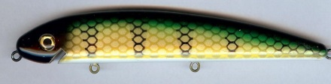  G-02 Perch | 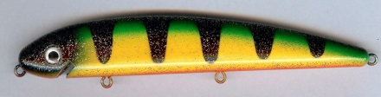  G-16 Glitter Perch | 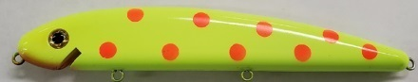  G-28 Chartreuse Firedot
G-03 Redhead | 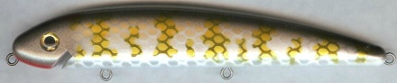  G-17 Muskie | 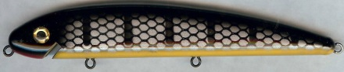  G-29 Black Sucker
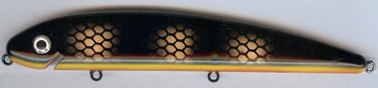  G-04 Black perch | 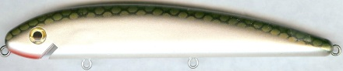  G-18 Tennessee Shad | G-38 Clown
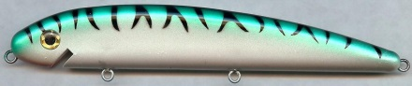  G-05 Green Mackerel | 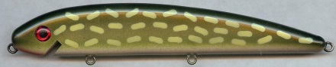  G-20 Northern Pike | 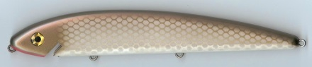  G-39 Alewife
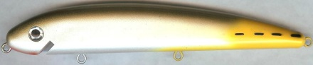  G-06 Jack | 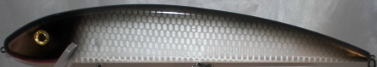  G-21 Silver Scale Black Back | 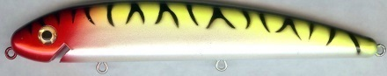  G-40 Tiger Clown
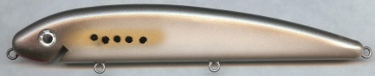  G-07 Bunker | 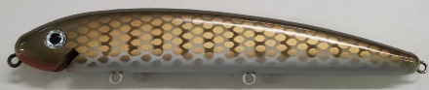  G-22 Brown Pikie | 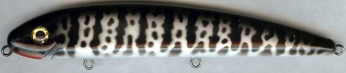  G-41 Crappie
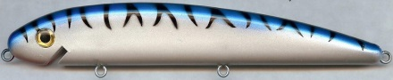  G-09 Blue Mullet | 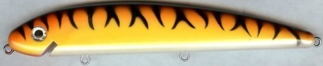  G-24 Orange Tiger | 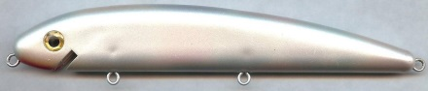  G-43 Mother Of Pearl
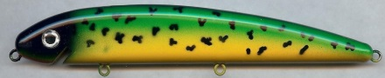  G-10 Dolphin | 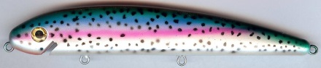  G-26 Rainbow Trout | 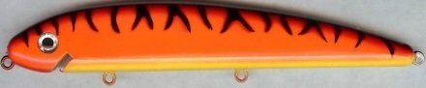  G-44 Hot Orange Tiger
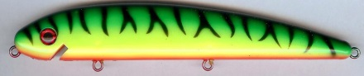  G-12 Firetiger | 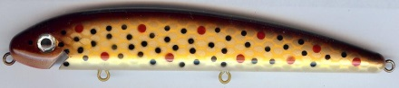  G-27 Brown Trout | 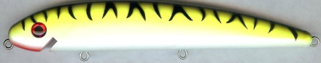  G-45 Chartreuse Tiger
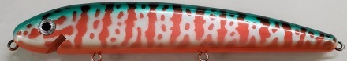  G-57 Blood Perch | 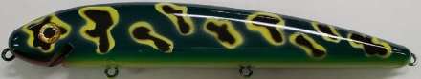  G-72 Dark Leopard Frog | 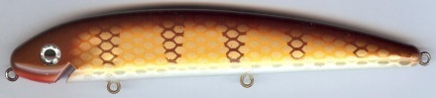  G-80 Brown Perch
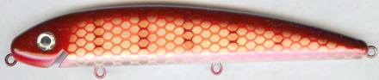  G-59 Redhorse | 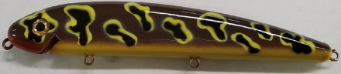  G-73 Brown Leopard Frog | 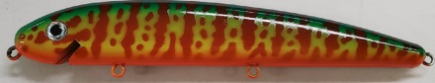  G-82 Fireside
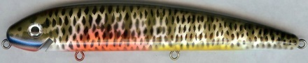  G-61 Blue Gill | 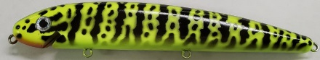  G-74 Chartreuse Crawdad | 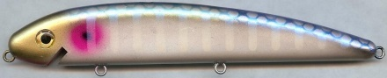  G-85 Neon Shad
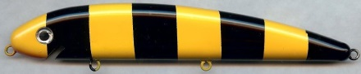  G-62 Bandit | 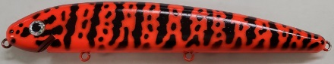  G-75 Hot Orange Crawdad | 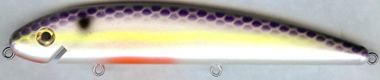  G-86 Super Shad
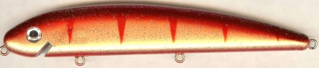  G-63 Red Perch | 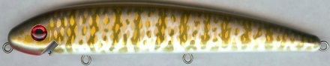  G-76 Smallmouth Bass | 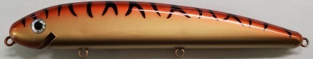  G-89 Red Lantern
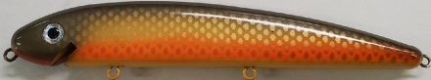  G-69 Carp | 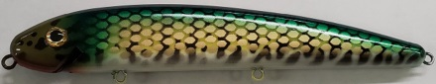  G-77 Hi-Tec Perch | 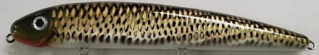  G-92 St Lawrence
Prism Models
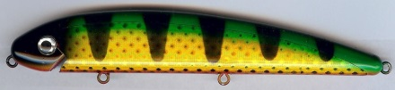  P-02 Prism Perch | 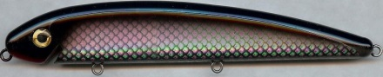  P-30 Silver Prism Black Back | 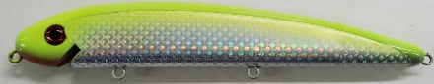  P-32 Silver Prism Chart. Back
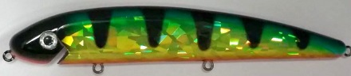  CCI-02 Chartreuse Cracked Ice Perch | 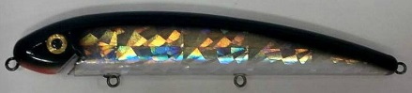  SCI-30 Silver Cracked Ice Black Back | 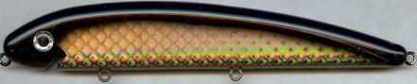  P-33 Gold Prism Black Back
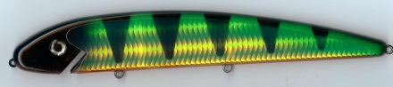  HTC-02 Hi-Tec Chartreuse Perch | 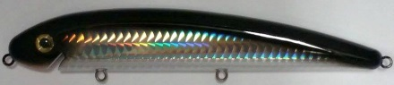  HTS-30 Hi-Tec Silver Black Back | 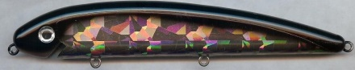  GCI-33 Gold Cracked Ice Black Back
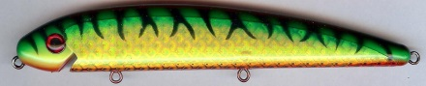  P-12 Prism Firetiger | 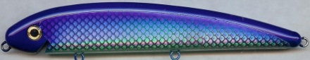  P-31 Silver Prism Blue Back | 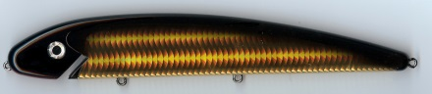  HTG-33 Hi-Tec Gold Black Back
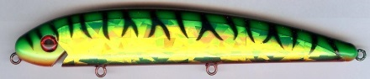  CCI-12 Chartreuse Cracked Ice Firetiger | 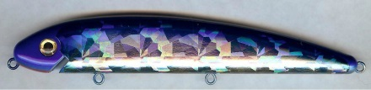  SCI-31 Silver Cracked Ice Blue Back | 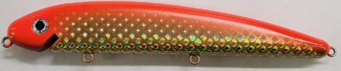  P-34 Gold Prism Hot Orange Back
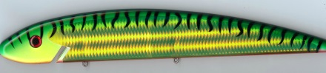  HTC-12 Hi-Tec Chartreuse Firetiger | 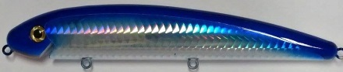  HTS-31 Hi-Tec Silver Blue back | 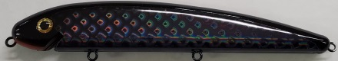  P-90 Black Widow
Holoform Models
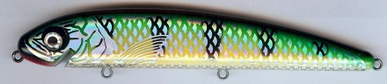  H-02 Holoform Perch | 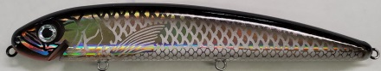  H-33 Gold Holoform Black Back | 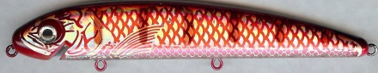  H-59 Holoform Redhorse
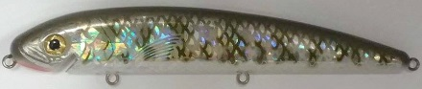H-17 Holoform Muskie | 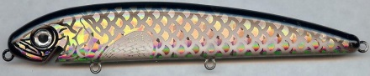  GLS-33 Gold Large Scale Black Back | 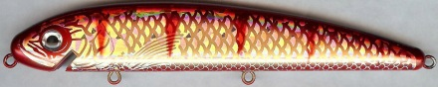  H-63 Holoform Red Perch
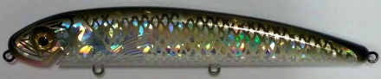  H-18 Holoform Tennessee Shad | 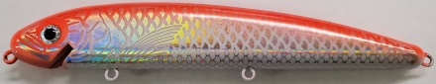  H-34 Gold Holo Hot Orange | 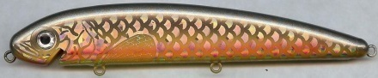  GLS-69 Large Scale Carp
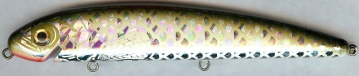  SLS-18 Large Scale Tennessee Shad | 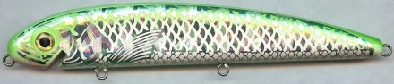  H-35 Holo Green Back | 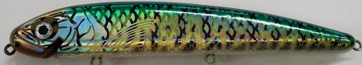  H-77 Holoform Hi-Tec Perch
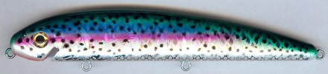  H-26 Holoform Rainbow Trout | 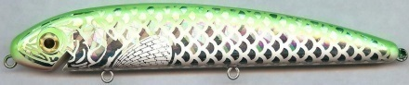  SLS-35 Large Scale Green Back | 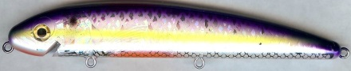  H-86 Holoform Super Shad
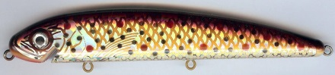  H-27 Holoform Brown Trout | 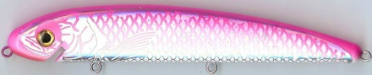  H-36 Holo Pink Back
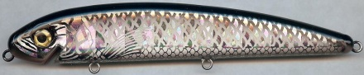  H-30 Silver Holoform Black Back | 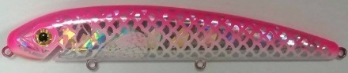  SLS-36 Large Scale Pink Back
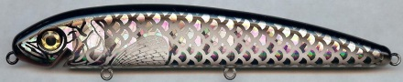  SLS-30 Silver Large Scale Black Back | 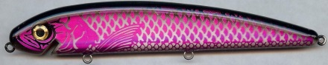  H-37 Purple Holo Black Back
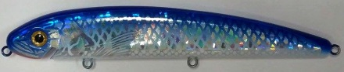  H-31 Holoform Blue Back | 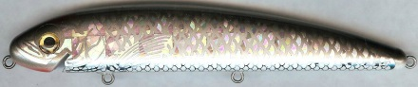  H-39 Holoform Alewife
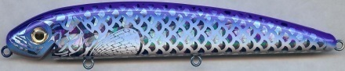  SLS-31 Silver Large Scale Blue Back | 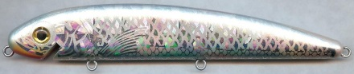  H-43 Holoform MOP
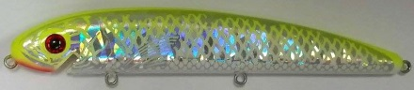  H-32 Holo Chartreuse Back | 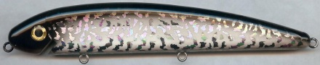  H-51 Silver Crazy Black Back
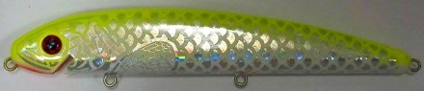  SLS-32 Large Scale Chartreuse Back | 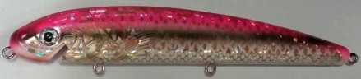  H-58 Holoform Darter

